**Project Proposal:** *PHP-SRePS*

|  |  |
| --- | --- |
| 3.2P | **101131147 | MONIQUE KUHN**  **101111372 | Jake Scott**  **102259710 | Tien Phu Ngo**  **101100655 | Lachlan Burns**  **102095118 | Jayden McQueen 102079989 | david stare**  Naurin Afrin| Friday 12.30  SWE30010 Development Project 2: Design, planning and Management |

**Background**

Please visit the project documentation generated up till this point at:

<https://github.com/Wabi-Mink/DP2_pass/wiki>

**Solution Direction**

The team has generated to possible directions for the project: a Java Web or a C#/Winforms local application. Each option presents its own strengths and weaknesses as identified and formatted in the following SWOT analysis tables.

**C# - Desktop Application w/ Local Storage**

|  |  |
| --- | --- |
| *Strength* | *Weakness* |
| * Commonly known language among team * Local storage is more secure * Visual Studio IDE is a fully supported environment we can use for free with C# | * **Backups required for local storage** * **Risk of loss of data** |
| *Opportunities* | ***Threat*** |
| * Easily converted to CSV format * More flexibility in creating a desktop application vs a web application, in terms of design and functionality | * **WinForms is unsupported** |

**Web Based Java Application**

|  |  |
| --- | --- |
| *Strength* | *Weakness* |
| * Commonly known language among team * Local storage is more secure * Visual Studio IDE is a fully supported environment we can use for free with C# | * **Backups required for local storage** * **Risk of loss of data** |
| *Opportunities* | ***Threat*** |
| * Easily converted to CSV format * More flexibility in creating a desktop application vs a web application, in terms of design and functionality | * **WinForms is unsupported** |

As a group, we have chosen to commit to creating a desktop application using C# and WinForms. As our database system, we have decided to use local storage as opposed to using MySQL on a web server. We believe this solution will be easier to use than a web server, as information cannot be stolen by outside sources, and it may be easier to use for the technologically inept. We have decided on creating a C# desktop application instead of a Java web application, as everyone in our group has had prior experience using C# and Visual Studio. No one in our group has had past experiences in developing Java. If we use C# and WinForms, we all have free access to the IDE Visual Studio through Swinburne, which will make coding our solution relatively stress-free in comparison to using Java, where we would have to use another IDE that we might not be familiar with.

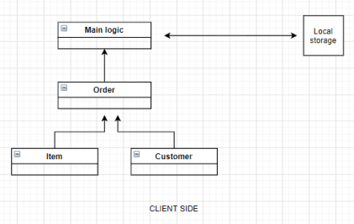**Solution Architecture**

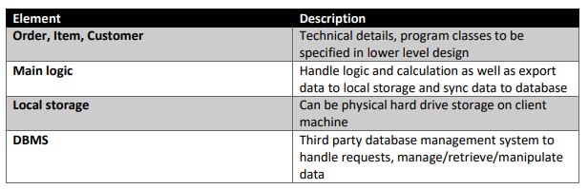

**Reflection**

**101111372 | Jake Scott**

The three design possibilities proposed by our group can be summarised as 'all online', 'data online & UI local', and 'all offline'. After a short discussion we agreed that we didn't have enough experience for a fully online java-based project, and that an online database - while better for the average client - might actually be worse for a small pharmacy (especially since they tend to use very old computer systems) - so we decided that a fully local solution would be the best option.

**102259710 | Tien Phu Ngo**

**101100655 | Lachlan Burns**

**102095118 | Jayden McQueen**

**101131147 | MONIQUE KUHN**